Kitten-Typewriter Piano
Our Piano will appear as a typewriter with forty-four keys. Every key will MEOW. The piano pedals will be from our three main kitten’s tails. The keyboard controls are mouse only. The three little kitties will randomly interfere with your playing to sit on the typewriter. It is up to you to be the monster that shoos them. The keys will break often and need mending. This is our integration of planned obsolescence. The following is the organisation system of keys. The top row will be CDEFGABC, the middle row will be CDEFGAB, and the bottom row will be [#]DEFGAB[b]. The space bar will be [low C] and B flat after it . Shift will create the following effects. Top row will become C5 -> C6, Middle row will become C4 -> B4 and the Bottom row will become D3 -> B3. The space bar will then be C3. # will cause the keys to go a semitone higher and a semitone lower with B flat. 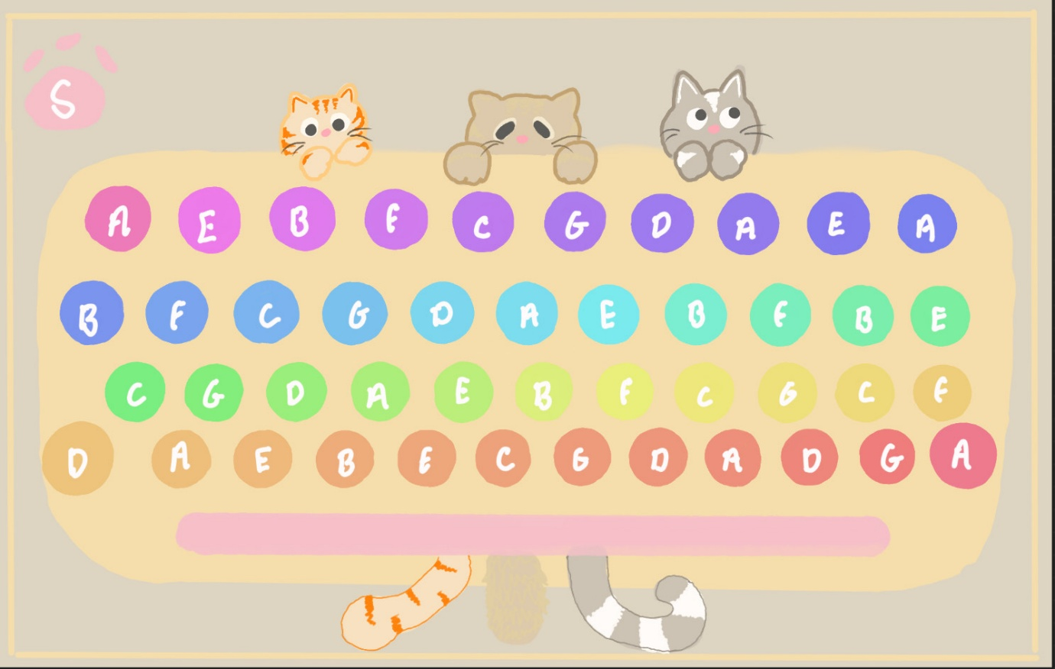
Keyboard Design, things to note. These are not the correct keys letters. S opens settings. Design wise the cat tails will appear emerging from underneath the typewriter not as depicted above. The kitten designs will remain the same. The buttons and typewriter background should appear more gradient and outlined.
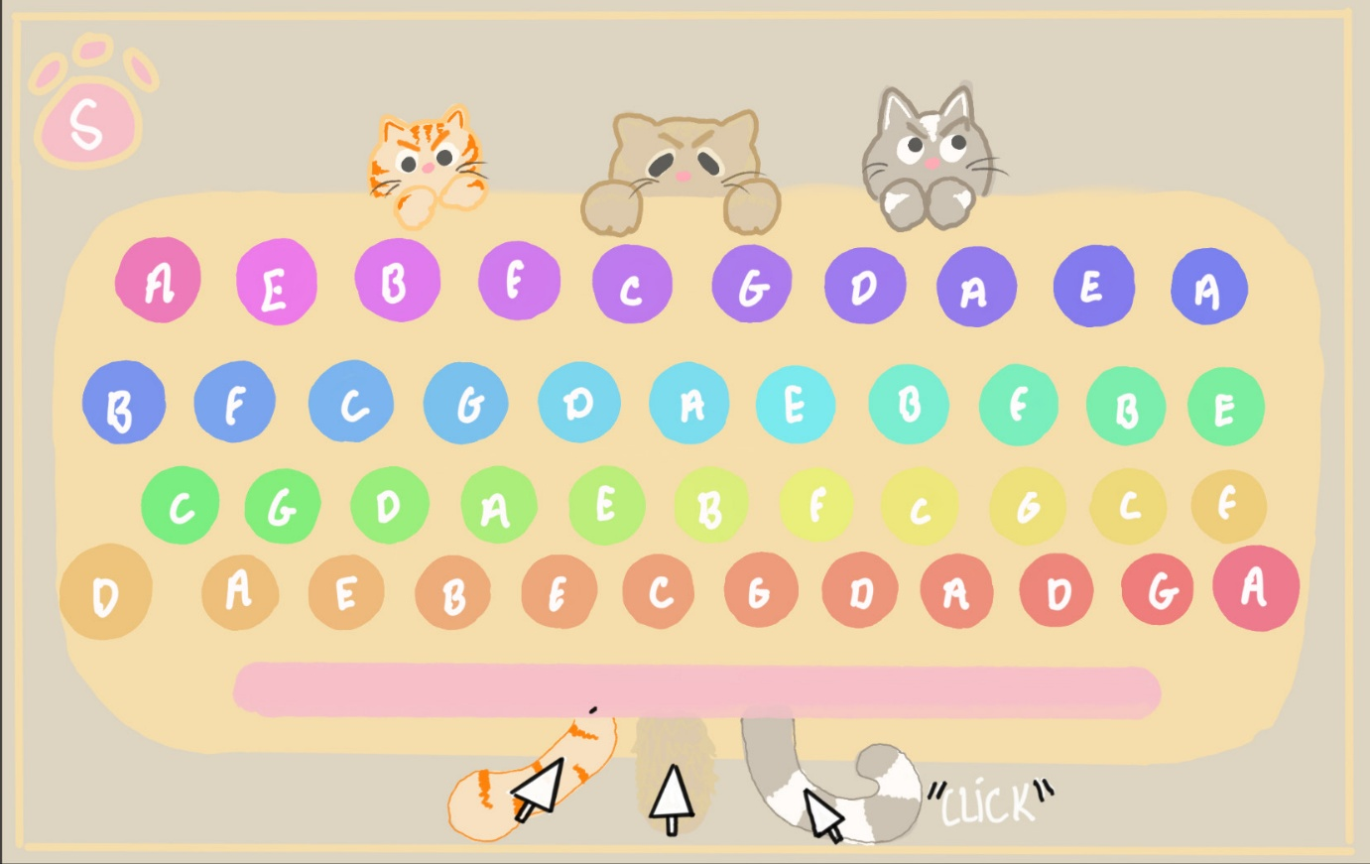
The kittens will stare at you aggressively if you use the pedals. 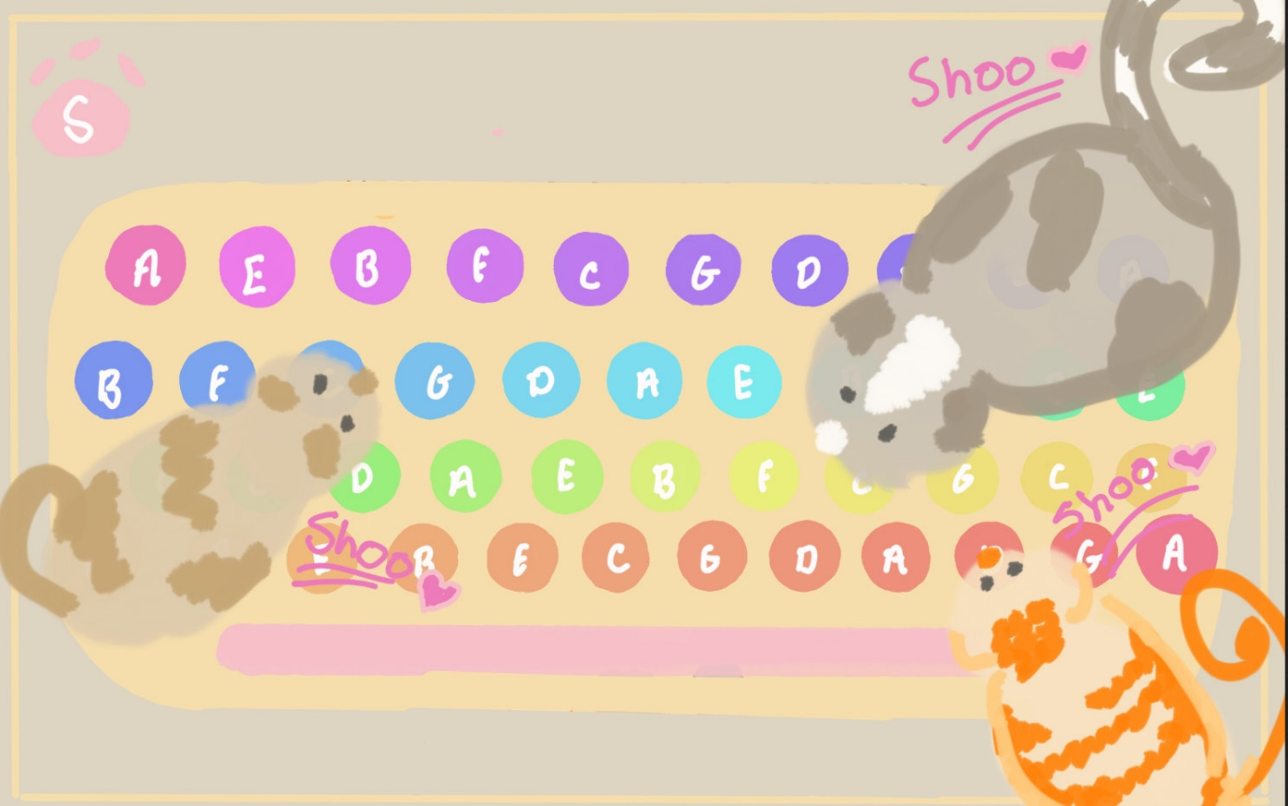
The kittens will randomly appear on top of the typewriter, and this may be often. They will also break keys because of this.
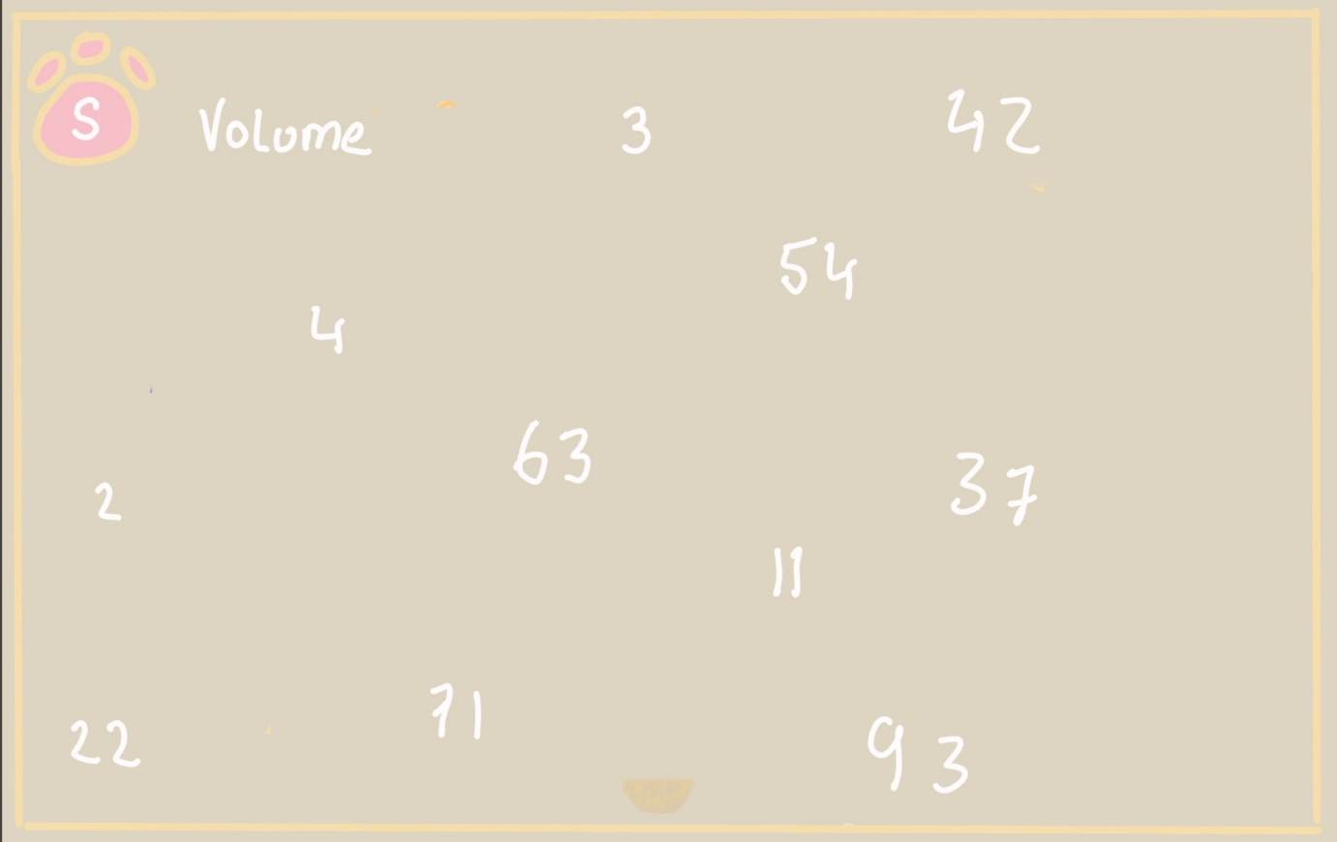
In settings there will be volume settings “floating around.” Hopefully, you can catch the number you are looking for. Design wise the numbers will be in a gradient sort of bubble with a nicer font.
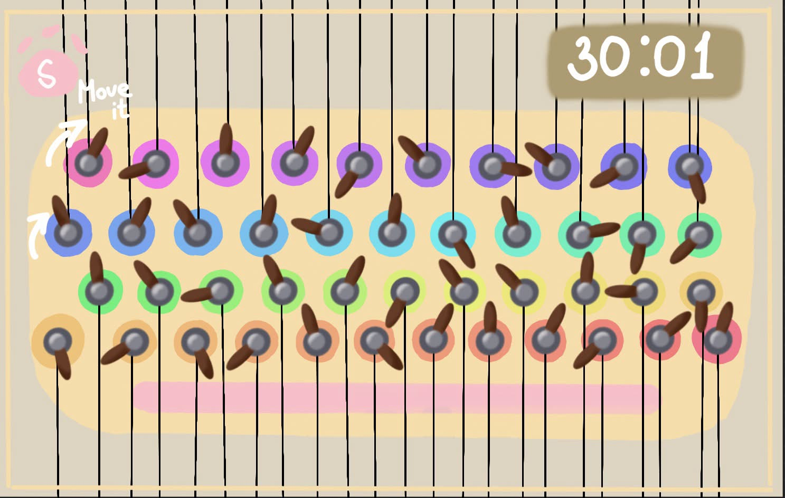
• Instead of a single screw, each button has its own separate one; the user turns it in a circle using the mouse until they set the correct note (perhaps we could add a sound or a small animation when it’s in the correct position) • The strings extend from the buttons off-screen to create a more unsettling visual for the user • On the timer in the top-right corner, the seconds and minutes have been deliberately swapped to confuse the user more at the start and subsequently (I think we’ll give this about a minute and a half, or around that, and experiment as we go)

